CCNA1 Chapter 5 Practice Test Questions

Which layer of the OSI model is the network layer?
- Layer 1
- Layer 2
- Layer 3
- Layer 4
- Layer 5
- Layer 6
- Layer 7

What name is given to a device that has an IPv4 address?

- Server
- Host
- Switch
- Workstation
- Router

The network layer PDU is called

- A frame
- A segment
- A packet
- A header

Which addresses are added during encapsulation at the network layer? Choose all that apply.

- Source IP address
- Source MAC address
- Source port number
- Destination IP address
- Destination MAC address
- Destination port number

An IPv4 address can be broken down into two parts. These are

- Network portion and transport portion
- Network portion and host portion
- Gateway portion and host portion
- Source portion and destination portion

What information from a packet does a router use in order to choose a route for forwarding the packet?

- Source port number
- Destination port number
- Host portion of destination IP address
- Host portion of source IP address
- Network portion of destination IP address
- Network portion of source IP address

What name is given to one stage of a packet’s journey as it moves from one router to the next?

- Trip
- Hop
- Step
- Section

Which statements are true of IPv4? Choose all that apply.

- It is connection-oriented
- It is connectionless
- It is best-effort
- It is reliable

What contact does IPv4 make with the destination before sending a packet?

- It sends a message to say that a packet will be arriving.
- It negotiates speed and timing parameters for the transfer.
- It checks that the destination host exists.
- It checks that the destination host is ready to receive.
- It does not make any contact before sending.

Which function is the responsibility of the network layer?

Encoding signals to put them on the transport medium.
Re-sending packets that have been lost in transmission.
Finding the best route for a packet to travel to its destination.
Managing the access of hosts to the transport medium.

How many bits make up an IPv4 address?

- 8
- 16
- 32
- 64

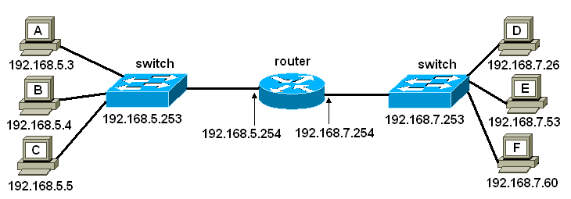

Refer to the diagram. What should be configured as the default gateway for host A?

- 192.168.5.3
- 192.168.5.253
- 192.168.5.254
- 192.168.7.254
- 192.168.7.253

Refer to the diagram. What is the address of the network that host D is on?

- 192.168.7.26
- 192.168.7.20
- 192.168.7.253
- 192.168.7.254
- 192.168.7.0
- 192.0.0.0

Refer to the diagram. If the default gateway configured on host A is wrong, what is the likely effect?

- Host A will not be able to communicate with any other host.
- Host A will be able to communicate with its local switch and router but not with any other workstation.
- Host A will be able to communicate with workstations B and C, but not D, E or F.
- Host A will be able to communicate with workstations D, E and F but not B or C.

Refer to the diagram. A packet header has destination IP address 192.168.5.4 and source IP address 192.168.7.60. Which workstation originated the packet?

- A
- B
- C
- D
- E
- F

Refer to the diagram. A packet header has destination IP address 192.168.5.4 and source IP address 192.168.7.60. Which workstation should receive the packet?

- A
- B
- C
- D
- E
- F

Refer to the diagram. Host A is sending a packet addressed to host F. What will the router do?

- It will use the destination IP address to work out the network address 192.168.7.0 and forward the packet to this network.
- It will use the destination IP address to work out the network address 192.168.5.0 and forward the packet to this network.
- It will use the source IP address to work out the network address 192.168.7.0 and forward the packet to this network.
- It will use the source IP address to work out the network address 192.168.5.0 and forward the packet to this network.

Refer to the diagram. The router receives a packet addressed to 192.168.6.24. What will the router do? (Choose 2 options.)

- The router will forward the packet to the 192.168.5.0 network.
- The router will forward the packet to the 192.168.7.0 network.
- The router will forward the packet to all connected networks.
- The router will return the packet to the source address.
- The router will send the packet on the default route if one exists.
- The router will drop the packet.

Why may a router have more than one IP address?

- It needs an address for incoming packets and an address for outgoing packets.
- Each router interface (port) is normally on a different network and needs an address on that network.
- It needs an address for communicating with hosts and separate addresses for communicating with other routers.
- It needs a separate address for each entry in its routing table.

Which is true of static routing?

- The router always sends packets on the same route.
- The router has been configured with a default route.
- Routes are entered manually by an administrator.
- The router learns routes from other routers.

Which field in the IP packet header allows some packets to have priority over others?

- Destination IP address
- Source IP address
- Type-of-service
- Time to live
- Checksum
- Protocol

Which field in the IP packet header allows checking for data transmission errors?

- Destination IP address
- Source IP address
- Type-of-service
- Time to live
- Checksum
- Protocol

Which field in the IP packet header is used to prevent undeliverable packets from circulating endlessly?

- Destination IP address
- Source IP address
- Type-of-service
- Time to live
- Checksum
- Protocol

When would a PC need a default gateway address?

- When it sends any packet.
- When it sends a packet to another PC on its own network.
- When it sends a packet to a host on a different network.
- When it does not know the IP address of the destination host.

What is a broadcast message?

- A message originated by a router.
- A message originated by a switch.
- A message addressed to all routers.
- A message addressed to all hosts on the local network.

Which device can limit the spread of broadcasts?

- Router
- Switch
- Hub
- Host

Which is true of dynamic routing?

- The router forwards packets through a different interface each time.
- The router has been configured with a default route.
- Routes are entered manually by an administrator.
- The router learns routes from other routers.

What do routers use to share routing information and keep their routing tables up to date?

- A routing protocol
- The network layer IP protocol
- The transport layer TCP protocol
- The transport layer UDP protocol

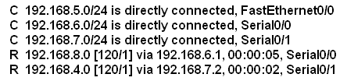

Part of the routing table of Router A is shown above. Which statements are true? (Select 3 options)

- One of the interfaces of Router A is on network 192.168.6.0.
- One of the interfaces of Router A is on network 192.168.8.0.
- Router A has 5 interfaces.
- The route to network 192.168.7.0 was learned from another router.
- The route to network 192.168.4.0 was learned from another router.
- 192.168.6.1 is the IP address of the serial 0/0 interface on Router A.
- 192.168.6.1 is the IP address of an interface on a neighbouring router.
- Packets addressed to 192.168.5.26 will be forwarded via a neighbouring router.
- Packets addressed to 192.168.4.71 can be forwarded directly to the destination host.

